Section 5.1: Slope

SOLs: A.7

Objectives: Students will be able to:
Find the slope of a line
Use rate of change to solve problems

Vocabulary:
Slope – the ratio of the change in y-coordinates (rise) to the change in x-coordinates (run)
the rise over the run or ∆y/∆x
Rate of Change – the average change over time (the slope is a rate of change with respect to x)

Key Concept:

Examples:
- Find the slope of the line that passes through (–3, 2) and (5, 5).

- Find the slope of the line that passes through (–3, –4) and (–2, –8).

- Find the slope of the line that passes through (–3, 4) and (4, 4).

- Find the slope of the line that passes through (–2, –4) and (–2, 3).

- Find the value of r so that the line through (6, 3) and (r, 2) has a slope of ½

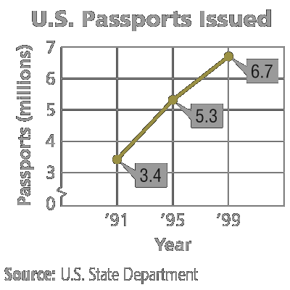
- Travel: The graph to the right shows the number of U.S. passports issued in 1991, 1995, and 1999.
Find the rates of change for 1991-1995 and 1995-1999.

Concept Summary:
The slope of a non-vertical line is the ratio of the rise to the run (∆y/∆x)
A vertical line has an undefined slope
A horizontal line has a zero slope

Homework: Pg. 260 16-46 even
Pg. 831 1-13 all
Section 5.2: Slope and Direct Variation

SOLs: The student will

Objectives: Students will be able to:
Write and graph direct variation equations
Solve problems involving direct variation

Vocabulary:
Constant of variation – the number k in equations the form y = kx
Graph – is a plot of an ordered pair (x,y) on the coordinate plane
Family of graphs – graphs and equations of graphs that have at least one characteristic in common
Parent graph – the simplest of the graphs in a family of graphs

Key Concept:

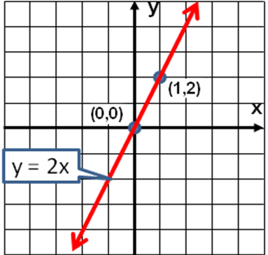
Examples:

- Name the constant of variation for the equation. Then find the slope of the line that passes through the pair of points.

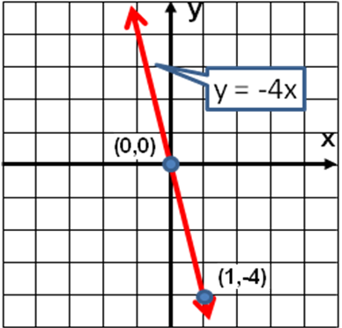
- Name the constant of variation for the equation. Then find the slope of the line that passes through the pair of points.

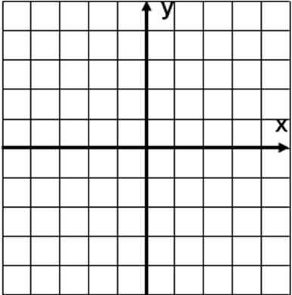

- Graph y = x

- Graph y = (-3/2)x

- Suppose y varies directly as x, and y = 9 when x = -3. Write a direct variation equation that relates x and y.

- Travel: The Ramirez family is driving cross-country on vacation. They drive 330 miles in 5.5 hours. Write a direct variation equation to find the distance driven for any number of hours.

Concept Summary:
A direct variation is described by an equation of the form y = kx, where k ≠ 0
In y = kx, k is the constant of variation. It is also the slope of the related graph

Homework: pg 268 16-46 even
Section 5.3: Slope-Intercept Form

SOLs: None

Objectives: Students will be able to:
Write and graph linear equations in slope-intercept form
Model real world data with an equation in slope-intercept form

Vocabulary:
Slope-intercept form - an equation of the form y = mx + b, where m is the slope and b is the y-intercept

Key Concept:

Examples:

- Write an equation of the line whose slope is (1/4) and whose y-intercept is –6.

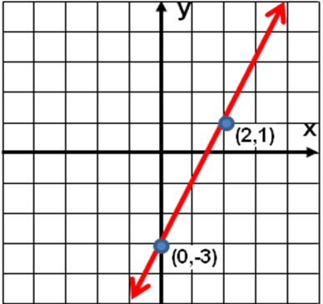

- Write an equation of the line shown in the graph to the right.

- Graph y = 0.5x – 7

- Graph 5x + 4y = 8

- Health: The ideal maximum heart rate for a 25-year-old who is exercising to burn fat is 117 beats per minute. For every 5 years older than 25, that ideal rate drops 3 beats per minute.
a. Write a linear equation to find the ideal maximum heart rate for anyone over 25 who is exercising to burn fat.
b. Find the ideal maximum heart rate for a person exercising to burn fat who is 55 years old.

Concept Summary:
The linear equation y = mx + b is written in slope-intercept form, where m is the slope and b is the y-intercept
Slope-intercept form allow you to graph an equation quickly
Slope-intercept form is only form allowed in the graphing calculator

Homework: Pg 275 14-32 even
Pg 831 1-12 all
Section 5.4: Writing Equations in Slope-Intercept Form

SOLs: The student will
G.3

Objectives: Students will be able to:
Write an equation of a line given the slope and one point on a line
Write an equation of a line given two points on a line

Vocabulary:
Linear extrapolation – the use of a linear equation to predict values that are outside the data range

Key Concept:
Examples:
- Write an equation of a line that passes through (2, –3) with slope ½

- Economy: In 2000, the cost of many items increased because of the increase in the cost of petroleum. In Chicago, a gallon of self-serve regular gasoline cost $1.76 in May and $2.13 in June. Write a linear equation to predict the cost of gasoline in any month in 2000, using 1 to represent January.

- Economy: The Yellow Cab Company budgeted $7000 for the July gasoline supply. On average, they use 3000 gallons of gasoline per month. Use the prediction equation y = 0.37x – 0.09 where x represents the month and y represents the cost of one gallon of gasoline, to determine if they will have to add to their budget. Explain.

Concept Summary:
To write an equation given the slope and one point, substitute the values of m, x, and y into the slope-intercept form and solve for b. Then write the slope-intercept form using the values of m and b
To write an equation given two points, find the slope. Then follow the steps above

Homework: pg 284 12-32 even
Section 5.5: Writing Equations in Point-Slope Form

SOLs: The student will
G.3 .

Objectives: Students will be able to:
Write the equation in a line in point-slope form
Write linear equations in different forms

Vocabulary:
Point-slope form - an equation of the form
y – y₁ = m(x – x₁), where m is the slope and (x₁,y₁) is a given point on a nonvertical line

Key Concept:
Examples:
- Write the point-slope form of an equation for a line that passes through (–2, 0) with slope (-3/2).

- Write the point-slope form of an equation for a horizontal line that passes through (0, 5).

- Write y = ¾x - 5 in standard form.

- Write y – 5 = (4/3)(x – 3) in slope-intercept form

Concept Summary:
The linear equation y – y₁ = m(x – x₁) is written in point-slope form, where (x₁, y₁) is a given point on a nonvertical line and m is the slope.

Homework: pg 289 16-26, 30-34, 42-48 even
Section 5.6: Geometry: Parallel and Perpendicular Lines

SOLs: None

Objectives: Students will be able to:
Locate points on the coordinate plane
Graph points on a coordinate plane
Write an equation of the line that passes through a given point, parallel to a given line
Write an equation of the line that passes through a given point, perpendicular to a given line

Vocabulary:
Coordinate plane – an x-y grid with axes as reference lines
Quadrant – the axes divide the coordinate plane into 4 regions or quadrants
Graph – is a plot of an ordered pair (x,y) on the coordinate plane
Parallel lines – lines in the same plane that never intersect and have the same slope
Perpendicular lines – lines that meet to form right angles

Key Concept:

Parallel lines have the same slope. Perpendicular lines’ slope multiplied together equal negative one.
Examples:
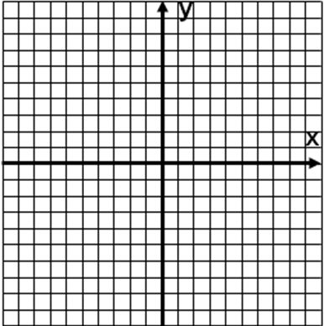
- Write the slope-intercept form of an equation for the line that passes through (4, –2) and is parallel to the graph of y = ½x – 7.

- Write the slope-intercept form for an equation of a line that passes through (4, –1) and is perpendicular to the graph of 7x – 2y = 3.

- Write the slope-intercept form for an equation of a line perpendicular to the graph of 2y + 5x = 2 and passes through (0, 6).

Concept Summary:
Two nonvertical lines are parallel if they have the same slope.
Two nonvertical lines are perpendicular if the product of their slopes is -1

Homework: pg 296 14-40 even
Section 5.7: Statistics: Scatter Plots and Lines of Fit

SOLs: None

Objectives: Students will be able to:
Interpret points on a scatter plot
Write equations for lines of fit

Vocabulary:
Scatter plot – Two sets of data plotted as ordered pairs in a coordinate plane
Positive correlation – in a scatter plot, as x increases, y increases
Line of fit – a line that describes the trend of the data in a scatter plot
Best-fit line – The line that most closely approximates the data in a scatter plot
Linear interpolation – The use of a linear equation to predict values that are inside of the data range
Negative correlation – in a scatter plot, as x increases, y decreases

Key Concept:
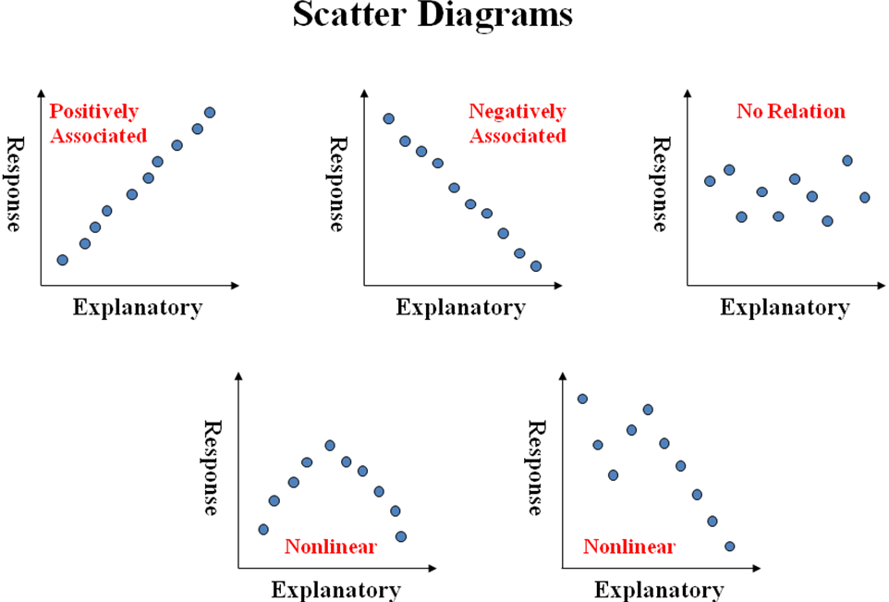

TI Instructions
Scatterplots Best Fit Line
- Enter explanatory variable in L1  - Enter response variable in L2  - Press 2nd y= for StatPlot, select 1: Plot1  - Turn plot1 on by highlighting ON and enter  - Highlight the scatter plot icon and enter  - Press ZOOM and select 9: ZoomStat | - With explanatory variable in L1 and response variable in L2  - Press STAT, highlight CALC and select  4: LinReg (ax + b) and hit enter twice  - Read off equation of best fit line
Examples:



- Determine whether the graph shows a positive correlation, a negative correlation, no correlation. If there is a positive or negative correlation, describe it.
a) b)

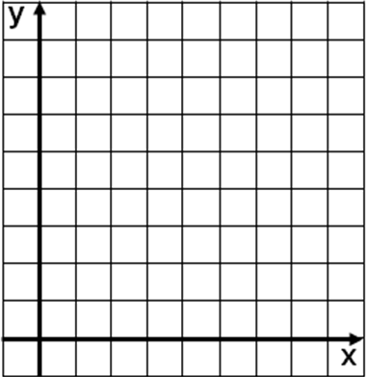
- The table shows the world population growing at a rapid rate.
a) Draw a scatter plot and determine what relationship exists, if any, in the data and draw a line of fit.
b) Write the slope-intercept form of an equation for equation for the line of fit.
Year | Population (millions)
1650 | 500
1850 | 1000
1930 | 2000
1975 | 4000
1998 | 5900

- Use the prediction equation y ≈ 33.1x – 60,235 where x is the year and y is the population (in millions), to predict the world population in 2010.

Concept Summary:
If y increases as x increases, then there is a positive correlation between x and y
If y decreases as x increases, then there is a negative correlation between x and y
If there is no relation between x and y, then there is no correlation between x and y
A line of fit describes the trend of data
You can use the equation of a line of the fit to make predictions about the data

Homework: none

